**Gulf Real Estate Properties**

Gulf Real Estate Properties, Inc., is a real estate firm located in southeast Florida. The company, which advertises itself as “expert in the real estate market,” monitors condominium sales by collecting data on location, list price, sale price, and number of days it takes to sell each unit. Each condominium is classified as *Gulf View* if it is located directly on the Gulf of Mexico or *No Gulf View* is it is located on the bay or a golf course, near but not on the Gulf. Sample data from the Multiple Listing Service in Naples, Florida, provided recent sales data for 40 Gulf View condominiums and 18 No Gulf View condominiums. Prices are in thousands of dollars. The data are shown in the table below.

|  |  |  |  |  |  |
| --- | --- | --- | --- | --- | --- |
| **Gulf View Condominiums** | | | **No Gulf View Condominiums** | | |
| **List Price** | **Sale Price** | **Days to Sell** | **List Price** | **Sale Price** | **Days to Sell** |
| 495.0 | 475.0 | 130 | 217.0 | 217.0 | 182 |
| 379.0 | 350.0 | 71 | 148.0 | 135.5 | 338 |
| 529.0 | 519.0 | 85 | 186.5 | 179.0 | 122 |
| 552.5 | 534.5 | 95 | 239.0 | 230.0 | 150 |
| 334.9 | 334.9 | 119 | 279.0 | 267.5 | 169 |
| 550.0 | 505.0 | 92 | 215.0 | 214.0 | 58 |
| 169.9 | 165.0 | 197 | 279.0 | 259.0 | 110 |
| 210.0 | 210.0 | 56 | 179.9 | 176.5 | 130 |
| 975.0 | 945.0 | 73 | 149.9 | 144.9 | 149 |
| 314.0 | 314.0 | 126 | 235.0 | 230.0 | 114 |
| 315.0 | 305.0 | 88 | 199.8 | 192.0 | 120 |
| 885.0 | 800.0 | 282 | 210.0 | 195.0 | 61 |
| 975.0 | 975.0 | 100 | 226.0 | 212.0 | 146 |
| 469.0 | 445.0 | 56 | 149.9 | 146.5 | 137 |
| 329.0 | 305.0 | 49 | 160.0 | 160.0 | 281 |
| 365.0 | 330.0 | 48 | 322.0 | 292.5 | 63 |
| 332.0 | 312.0 | 88 | 187.5 | 179.0 | 48 |
| 520.0 | 495.0 | 161 | 247.0 | 227.0 | 52 |
| 425.0 | 405.0 | 149 |  |  |  |
| 675.0 | 669.0 | 142 |  |  |  |
| 409.0 | 400.0 | 28 |  |  |  |
| 649.0 | 649.0 | 29 |  |  |  |
| 319.0 | 305.0 | 140 |  |  |  |
| 425.0 | 410.0 | 85 |  |  |  |
| 359.0 | 340.0 | 107 |  |  |  |
| 469.0 | 449.0 | 72 |  |  |  |
| 895.0 | 875.0 | 129 |  |  |  |
| 439.0 | 430.0 | 160 |  |  |  |
| 435.0 | 400.0 | 206 |  |  |  |
| 235.0 | 227.0 | 91 |  |  |  |
| 638.0 | 618.0 | 100 |  |  |  |
| 629.0 | 600.0 | 97 |  |  |  |
| 329.0 | 309.0 | 114 |  |  |  |
| 595.0 | 555.0 | 45 |  |  |  |
| 339.0 | 315.0 | 150 |  |  |  |
| 215.0 | 200.0 | 48 |  |  |  |
| 395.0 | 375.0 | 135 |  |  |  |
| 449.0 | 425.0 | 53 |  |  |  |
| 499.0 | 465.0 | 86 |  |  |  |
| 439.0 | 428.5 | 158 |  |  |  |

**Managerial Report**

1. Use appropriate descriptive statistics to summarize each of the three variables for the 40 Gulf View condominiums.
2. Use appropriate descriptive statistics to summarize each of the three variables for the 18 No Gulf View condominiums.
3. Compare your summary results. Discuss specific statistical results that would help a real estate agent understand the condominium market.
4. Develop a 95% confidence interval estimate of the population mean sales price and population mean number of days to sell for Gulf View condominiums. Interpret your results.
5. Develop a 95% confidence interval estimate of the population mean sales price and population mean number of days to sell for No Gulf View condominiums. Interpret your results.
6. Assume the branch manager requested estimates of the mean selling price of Gulf View condominiums with a margin of error of $40,000 and the mean selling price of No Gulf View condominiums with a margin of error of $15,000. Using 95% confidence, how large should the sample sizes be?
7. Gulf Real Estate Properties just signed contracts for two new listings: a Gulf View condominium with a list price of $589,000 and a No Gulf View condominium with a list price of $285,000. What is your estimate of the final selling price and number of days required to sell each of these units?

1. Using Miniatab we obtain the appropriate descriptive statistics to summarized each of the three variables for the 40 gulf view condom and the output is as shown below:

|  |  |  |  |  |  |  |  |  |  |  |  |  |  |  |  |  |  |
| --- | --- | --- | --- | --- | --- | --- | --- | --- | --- | --- | --- | --- | --- | --- | --- | --- | --- |
| Variable | count | mean | SE mean | StDev | Variance | Sum | Min | Q1 | med | Q3 | Max | Range | IQR | MODE | MODE | skewness | kurtosis |
| GV list price | 40 | 474 | 31.2 | 197.3 | 38923.4 | 18960.3 | 169.9 | 332.7 | 437 | 551.9 | 975 | 805.1 | 219.1 | 329 425 439 469 | 2 | 1.1 | 1.01 |
| GV sale price | 40 | 454.2 | 30.4 | 192.5 | 37063.1 | 18168.9 | 165 | 314.3 | 417.5 | 530.6 | 975 | 810 | 216.4 | 305 | 3 | 1.16 | 1.18 |
| GV days | 40 | 106 | 8.26 | 52.22 | 2726.51 | 4240 | 28 | 71.25 | 96 | 138.75 | 282 | 254 | 67.5 | 48 56 85 88 | 2 | 1.08 | 2.02 |
| The data contain at least five mode values， only the smallest four are shown. | | | | | | | | | | | | | | | | | |

The 3 variables are list price,sale price and number of days.

2.Using Miniatab we obtain the appropriate descriptive statistics to summarized each of the three variables for the 18 Non- gulf view condom and the output is as shown below:

|  |  |  |  |  |  |  |  |  |  |  |  |  |  |  |  |  |  |
| --- | --- | --- | --- | --- | --- | --- | --- | --- | --- | --- | --- | --- | --- | --- | --- | --- | --- |
| Variable | count | mean | SE mean | StDev | Variance | Sum | Min | Q1 | med | Q3 | Max | Range | IQR | MODE | MODE | skewness | kurtosis |
| NGV list price | 18 | 212.8 | 11.5 | 48.9 | 2395.6 | 3830.5 | 148 | 174.9 | 212.5 | 241 | 322 | 174 | 66.1 | 149.9 279 | 2 | 0.54 | -0.09 |
| NGV sale price | 18 | 203.2 | 10.3 | 43.9 | 1926.5 | 3657.4 | 135.5 | 172.4 | 203.5 | 230 | 292 | 157 | 57.6 | 179 230 | 3 | 0.3 | -0.46 |
| NGV days | 18 | 135 | 18 | 76.3 | 5821.6 | 2430 | 48 | 62.5 | 126 | 154.8 | 338 | 290 | 92.3 | * | 0 | 1.36 | 2.22 |

The 3 variables are list price,sale price and number of days.

3.We comparing the summary results we construct the histograms for each group as follow:

.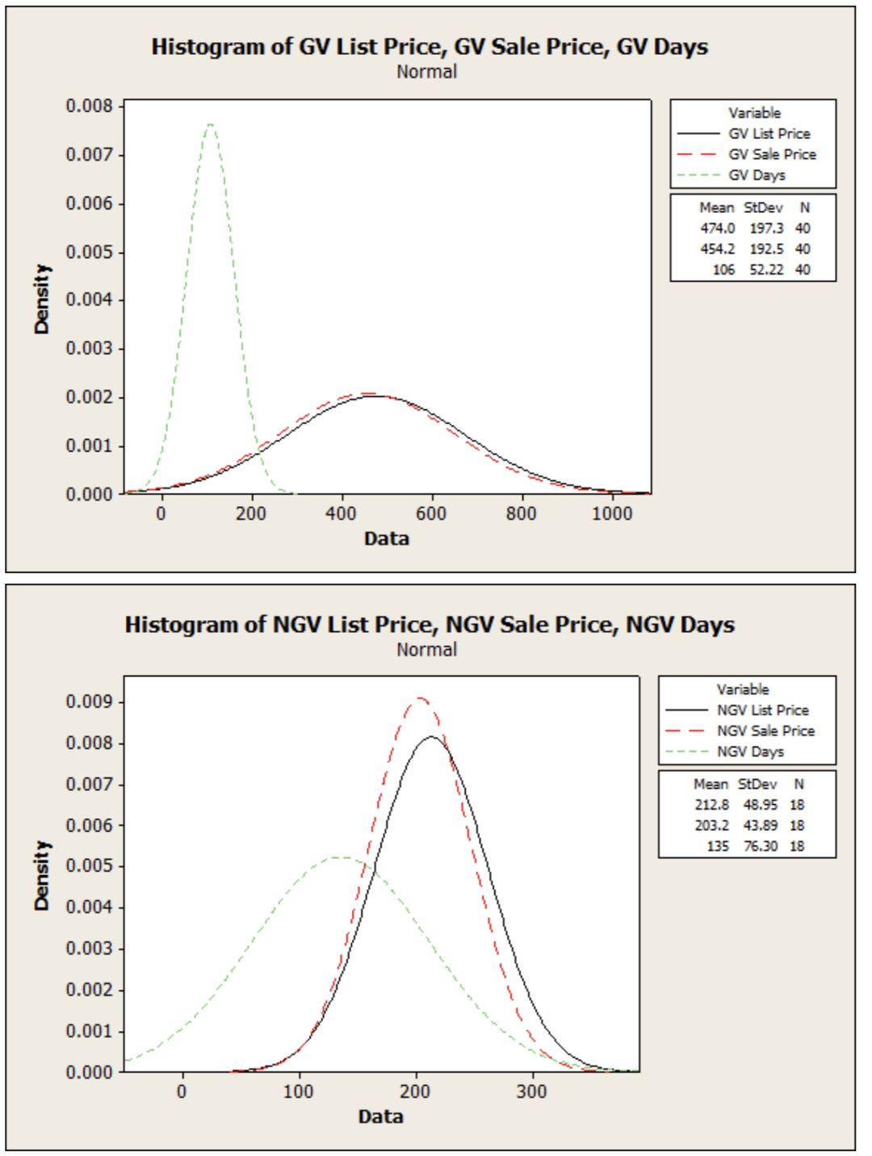

From the above histogram we compare the summary results in GV list price in the shape of leptokurtotic and it is in NGV list price in the shape of mesokurtotic. Also the GV sale price and GV days in the shape of platykurtotic and it is peaked to leptokurtotic in NGV condo. The statistics results that would help a real estate agent understand and condo market.

1. Using Minitab to develop a 95%confidence interval estimate of the population mean sales price and population mean number of days to sell for Gulf view condo.the obtained output is as shown below:

|  |  |  |  |  |  |
| --- | --- | --- | --- | --- | --- |
| sample :GV SALE PRICE | | | | | |
| the assumed standard deviation=192.5 | | | | | |
| Variable | N | MEAN | STDEV | SEMEAN | 95%CI |
| GV sale price | 40 | 454.2 | 192.5 | 30.4 | 394.6 513.9 |

|  |  |  |  |  |  |
| --- | --- | --- | --- | --- | --- |
| sample :GV DAYS | | | | | |
| the assumed standard deviation=52.22 | | | | | |
| Variable | N | MEAN | STDEV | SEMEAN | 95%CI |
| GV days | 40 | 106 | 52.22 | 8.26 | 89.82 122.18 |

5.Using Minitab to develop a 95%confidence interval estimate of the population mean sales price and population mean number of days to sell for N-Gulf view condo.the obtained output is as shown below：

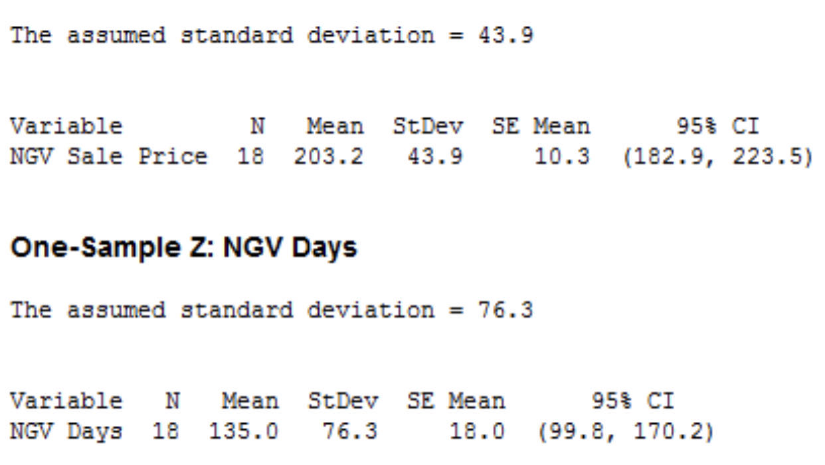

6.From the information ,by using stat we find the sample size selling price of Gulf view condo and N-Gulf view condo the output is as follows:

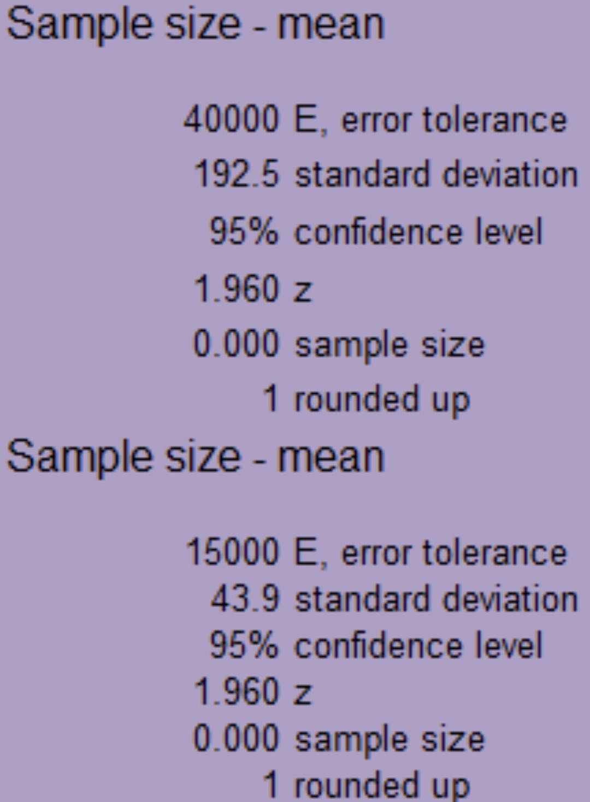

1. it is given that a gulf view condo with a list price of $589,000 and no gulf view condo with a list price of $285,000.we need a estimate of the final selling price and number of days required selling each of these units.By using regression analysis to predict the final selling price and number of days required selling each of these units as follows.Let X denote the list price which is an independent variable day Y denote selling price,which is dependent variable.

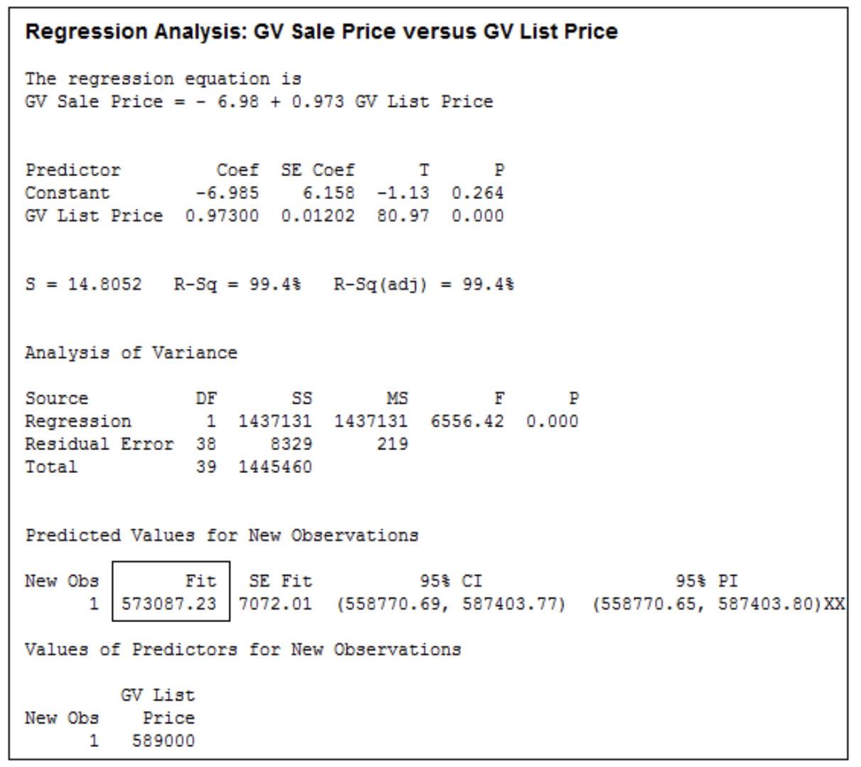

**Metropolitan Research, Inc.**

Metropolitan Research, Inc., a consumer research organization, conducts survey designed to evaluate a wide variety of products and services available to consumers. In one particular study, Metropolitan looked at consumer satisfaction with the performance of automobile produced by a major Detroit manufacturer. A questionnaire sent to owners of one of the manufacturer’s full-sized cars revealed several complaints about early transmission problems. To learn more about the transmission failures, Metropolitan used a sample of actual transmission repairs provided by a transmission repair firm in the Detroit area. The following data show the actual number of miles driven for 50 vehicles at the time of transmission failure.

|  |  |  |  |  |  |  |  |
| --- | --- | --- | --- | --- | --- | --- | --- |
| 85,092 | 32,609 | 59,465 | 77,437 | 32,534 | 64,090 | 32,464 | 59,902 |
| 39,323 | 89,641 | 94,219 | 116,803 | 92,857 | 63,436 | 65,605 | 85,861 |
| 64,342 | 61,978 | 67,998 | 59,817 | 101,769 | 95,774 | 121,352 | 69,568 |
| 74,276 | 66,998 | 40,001 | 70,069 | 25,066 | 77,098 | 69,922 | 35,662 |
| 74,425 | 67,202 | 118,444 | 53,500 | 79,294 | 64,544 | 86,813 | 116,269 |
| 37,831 | 89,341 | 73,341 | 85,288 | 138,114 | 53,402 | 85,586 | 82,256 |
| 77,539 | 88,798 |  |  |  |  |  |  |

**Managerial Report**

1. Use appropriate descriptive statistics to summarize the transmission failure data.
2. Develop a 95% confidence interval for the mean number of miles driven until transmission failure for the population of automobiles with transmission failure. Provide a managerial interpretation of the interval estimate.
3. Discuss the implication of your statistical findings in terms of the belief that some owners of the automobiles experienced early transmission failures.
4. How many repair records should be sampled if the research firm wants the population mean number of miles driven until transmission failure to be estimated with a margin of error of 5000 miles? Use 95% confidence.
5. What other information would you like to gather to evaluate the transmission failure problem more fully?

1.n= 50

mean =1/n\sum xi

=73340

Standard deviation =\sqrt{1/n\sum xi^2-\bar{x}^2}

=24899

Standard Error =standard deviation/\sqrt{n}

=3521

Minimum = 25066

Maximum= 138114

Q1=59881

Q3= 87309

2.

95% confidence interval for mean is (mean\pm 1.96* standard error)

=(73340 -1.96 *3521, 73340+1.96*3521)

=(66438.84, 80241.16)

3.

we believe that there is a problem with early transmission failures based on this sample. standard error is very high also confidence interval.

4.

Getting standard deviation s= 24899

n=z(alpha/2)2 s2/E2

where alpha/2 =(1- confidence level)/2 =0.025

Using table,

z(alpha/2) = 1.959963985 Also,

s=sample standard deviation =24899

E = margin of error = 5000

n= 95.26206335

rounding up

n=96

5.The variables may be capacity of car engine, Neglecting oil changes, Overlooking oil leaks, Flooding your engine